**Trabajo de Ingles-Escuela PrivadaTaragüi**

**Actividades de Ingles**

**4to año**

**Contenidos a trabajar: Presente Simple / Reading** “**Self-Esteem”**

**Entrega del trabajo hasta el 3 de abril (a más tardar)**

* Les dejo en esta primera hoja un resumen de la teoría del Presente Simple para que vuelvan a repasar este tema, en la siguiente hoja tienen tres ejercicios para practicar esta teoría.
* Luego tienen un texto para leer y contestar dos preguntas sobre el mismo.
* La última actividad es un escrito que lo van a hacer sobre ustedes respondiendo el punto “C” y escribiendo entre 100 - 150 palabras, en lo posible utilicen solo el Presente Simple
* Por cualquier consulta recuerden que en la página de la escuela esta mi correo
* Dejo también un código para la aplicación ***Google Classroom***, así también si tienen dudas o consultas me comunican por ese medio: **ig7ic3c**

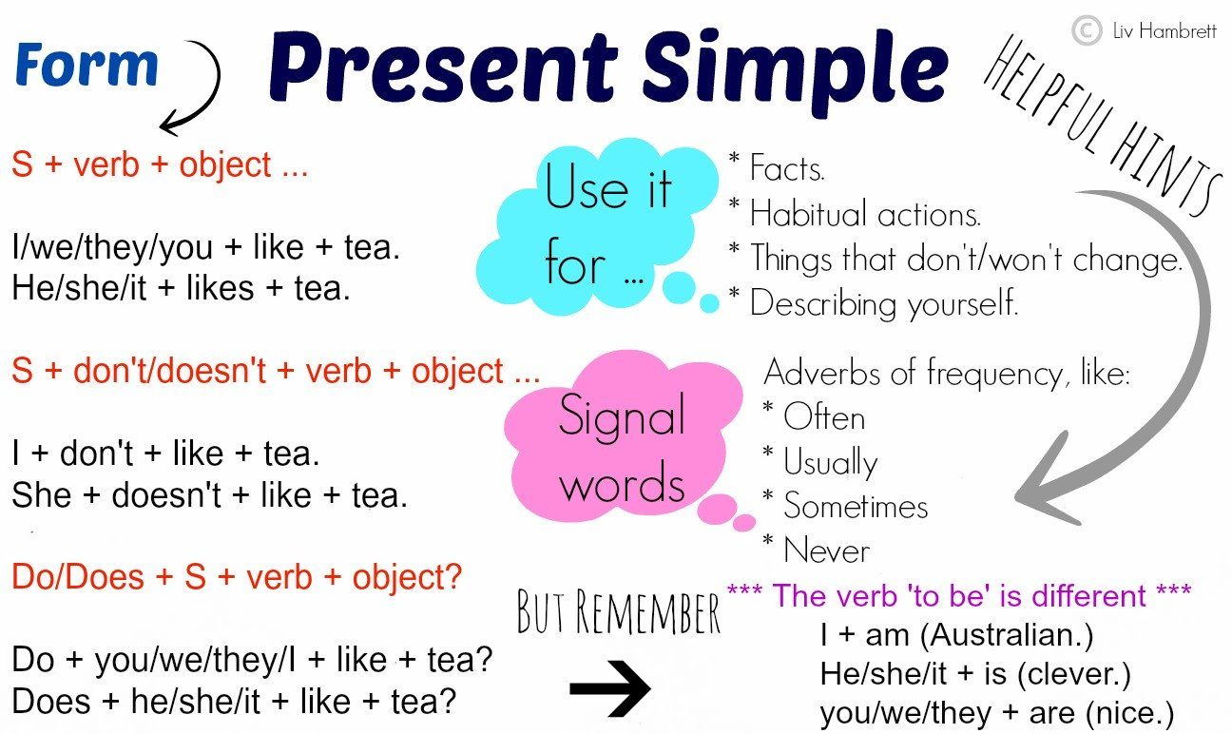 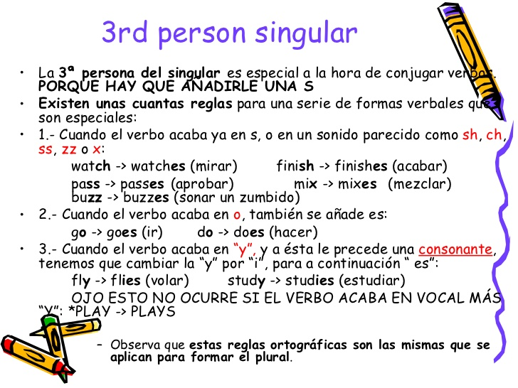

**Grammar: Present Simple**

**1.Read and complete the sentences.**

1. My best friend ______**_*live***______(+, *live*) in Pittsburgh. He_____________________ (+, *love*) baseball.

2. He _____________(+, *wear*) his blue baseball cap every day. We like the same team!

3. We _______________(+, *play*) football together in the afternoons. We love sports!

4. Erick_______________________ (–, *criticise*) me. He listens to my problems.

5. We__________________ (–, *argue*) either. We are great friends!

6. I sometimes_________________ (+, *get*) jealous of Erick because he’s good at everything!

7. But then I___________________ (+, *remember*) that I am lucky to be his friend!

**2.Write questions using *Do* and *Does*.**

1. like / you / history / ? ***Do you like history?***

2. like / you / chemistry / ? _________________

3. use / you / an / eraser / ? _________________

4. your / family / listen / to / you / ? _________________

5. have / your / mum / breakfast / ? _________________

6. you / ever / forget / your / homework / ? _________________

**3.Complete the sentences with the negative (–) form of the verbs in brackets.**

1. My sister ____***Doesn´t like***__________(*like*) fish.

2. I _____________(*study*) on Fridays.

3. My teacher ______________(*tell*) jokes in class.

4. You ________________(*participate*) in class often!

5. We _________________(*go*) to the gym at weekends.

6. My dad _______________(*wear*) glasses.

**Reading: What is Self-Esteem?**

Self-esteem is what you think of yourself. It is important because it can affect your physical and emotional health. Good self-esteem can make you happy and healthy. Low self-esteem can make you unhappy and unwell.

People with good self-esteem...

• like focusing on their good qualities.

• like thinking positively about themselves.

• like having balanced opinions of themselves.

People with low self-esteem...

• like focusing on their bad qualities.

• can think negatively about themselves.

• can feel very bad about their mistakes.

Here are things you can do to improve your self-esteem: be aware of your thoughts. Are they always negative? Don’t think, ‘I’m terrible at this.’ Think, ‘I need more time to understand this,’ or ‘I need some help with this.’ Remember that everyone can make mistakes and everyone has got good qualities... and you too!

1. **Read and complete the sentences with the words.**

*good / health / help / low / self-esteem / unhappy*

1. What you think of yourself is ___________.

2. People with a healthy self-esteem can focus on their _________qualities.

3. People who like focusing on their mistakes have got _____________self-esteem.

4. Self-esteem can affect your physical and emotional__________ .

5. Low self-esteem can make you______________ .

6. People with good self-esteem can ask for________________ .

1. **Read and match the opposites.**

1. good A. unwell

2. happy B. negatively

3. healthy C. bad

4. positively D. unhappy

1. **Stop and Think! What do you like about yourself? Describe your positives qualities. Write a paragraph of 100-150 words**